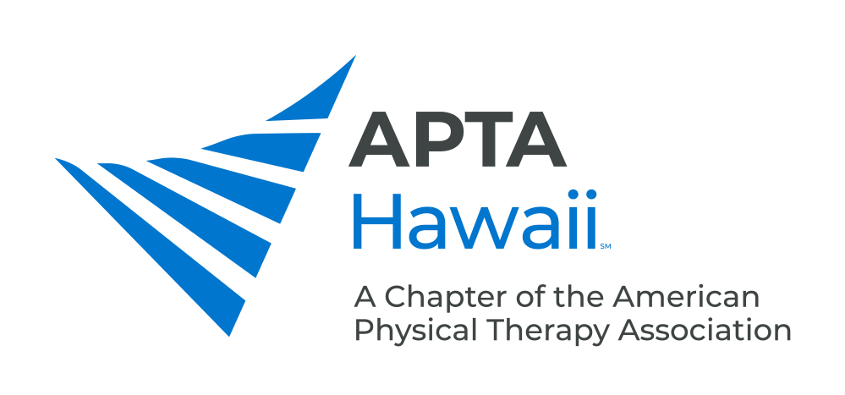

District Ambassador Program

What is the District Ambassadors Program?
The District Ambassadors Program was created by APTA Hawaii in 2021. The program will consist of two-three appointed district ambassadors for each of the largest four counties (Oahu, Kauai, Maui, Big Island) who will act as liaisons for their region to allow for improved communication between the physical therapy community and APTA Hawaii.

Why was program created?
The District Ambassadors Program was created in order to help APTA Hawaii better serve the physical therapy community in Hawaii. APTA Hawaii recognizes that each county region in the state has specific challenges and needs that are likely best identified by those PTs, PTAs, and PT/PTA students that live and work in each region. The District Ambassadors will be the link between each county and APTA Hawaii. Ultimately, this will create strength in the physical therapy profession and the Hawaii PT community which has faced numerous challenges recently. Our goal is find out what ALL PTs and PTAs need, and feel that a representative native to their country will know those needs best!

How many District Ambassadors will there be and how are they chosen?
There will be two-three ambassadors chosen for each county. Any licensed physical therapist or physical therapist assistant, currently practicing in the county, will be able to nominate a PT, a PTA, or a PT or PTA student for the District Ambassador positions. APTA membership is not required.
Nominations should be submitted using this form and sent to meynardpt@gmail.com.
Final nominees will be announced and voted on by other PTs, PTAs, and PT/PTA students from the county they’ve been nominated to serve in.

What are duties of the District Ambassadors and how long is the appointment?
- District Ambassadors are liaisons between their respective regions and APTA Hawaii.
- They will have the knowledge of their individual regions, the needs of the physical therapy community unique to their region.
- Needs Assessment: DA will communicate with PTs, PTAs, and clinics around their area to be able to identify challenges and needs within their region where the APTA Hawaii might be of service.
- They will add/modify/update the resource list of physical therapists and clinics within their region.
- District ambassadors will participate in quarterly District Ambassadors virtual meetings with other ambassadors from other counties as well as an APTA Hawaii representative.
- Continued communication: DA’s will continue communication with PTs in their region, informing them of projects within the chapter, news and changes within national APTA, reassessing effectiveness of any projects for their region, updating the chapter with additional needs or barriers to successful practice.
- District Ambassadors are appointed for one year.

What are the benefits of being a District Ambassador?
- Ensure that the needs of your region are identified and addressed by the APTA Hawaii.
- District Ambassador is a stepping to stone to future leadership positions, including elected office in APTA Hawaii.
- Great networking opportunities with clinics within their respective region as well as the entire state.
- Know first hand about any changes at the state and national level that may affect PT practice
- Being a District Ambassador is a great gateway to getting involved at the national level which carries many opportunities for national travel.
- Be a voice for your physical therapy community, and do something productive and meaningful outside patient care.
- As a volunteer of the APTA Hawaii, there are possible benefits in CEU and other discounts

What characteristics should a District Ambassador have?
- Willingness to identify challenges for PTs, PTAs, and clinics within their region.
- People person who will ensure that the voice of their regional constituents are heard.
- Desire to bring PTs, PTAs, and PT/PTA students together and to strengthen the physical therapy profession.
- Be part of a community with similar goals to improve physical therapy.

How do I get more information about the District Ambassadors program?
Contact Meynard Enriquez PT, DPT, OCS, FAAOMPT (APTA Centennial Scholar/APTA Hawaii Public Relations Chair) at meynardpt@gmail.com

