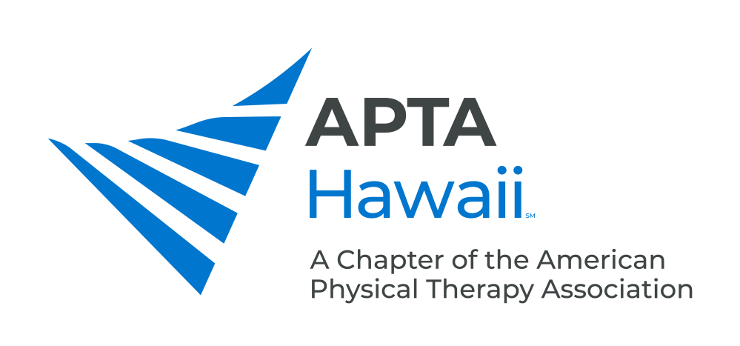 H

District Ambassador Job Description

District Ambassadors Program - Introduction
The District Ambassadors Program was created by APTA Hawaii in 2021. The program will consist of two-three appointed district ambassadors for each of the largest four counties (Oahu, Kauai, Maui, Big Island) who will act as liaisons for their region to allow for improved communication between the physical therapy community and APTA Hawaii.

Job Description
- Communication with clinics within their respective regions as a means of outreach.
  - Methods: in person, email, and phone
  - Introduction of District Ambassadors Program
  - Establish needs within their region for which APTA Hawaii can be a vessel for change
  - Let clinics know of programs/events sponsored by APTA Hawaii to help reinforce Chapter marketing
  - Educate clinics on the benefits of membership and recruit potential members
  - Update the resource list about new clinics within their region
  - Organize two regional social events for members and potential members each year

- Communication with the board
  - DA are required to attend bi-monthly APTA Hawaii board meetings
  - Coordinate with Membership Committee about the progress of outreach

- Communication with other DA from other islands
  - A total of three virtual meetings will take place (Introductory, 1/2 year update, and 1 year wrap up)
  - Year wrap up may be in person

District Ambassador Benefits
- Be at the forefront of making positive change in the APTA Hawaii
- Be a change agent in making APTA Hawaii the Chapter you always wanted
- Ensure that the needs of your region are identified and addressed by the APTA
- District Ambassador is a stepping stone to other leadership positions, included elected positions
- Great networking opportunities with clinics within your respective region as well as the entire state
- An opportunity to be learn first hand about any changes at the state and national level that may affect PT practice
- Being a District Ambassador is a great gateway to getting involved at the national level which carries many opportunities for national travel
- Be a voice for your physical therapy community, and do something productive and meaningful outside patient care.
- As a volunteer for APTA Hawaii, there are possible benefits in CEU and other discounts

District Ambassador Point of Contact
Contact Meynard Enriquez PT, DPT, OCS, FAAOMPT (APTA Centennial Scholar) at meynardpt@gmail.com

